1. Hello everyone! Welcome to our presentation.

We are Juan Rico, Brayan Garzon, Santiago Valdes, Mauricio Polanco and Saira Guevara, apprentices of the technology in Software Analysis and Development, code number: 2500871.

We are happy to be here to talk about our project called WELL-BEING.

1. Our project consists on the creation of a software for the apprentice well-being area. It will have the functionalities of creating announcements for the apprentices in transportation service, food, managing of applications, benefit assignation, and generating assistance reports which will facilitate the tasks developed for the well-being area. It is important to highlight that our project was created from scratches.

Here you can observe the steps to log in the apprentice WELL-BEING page:

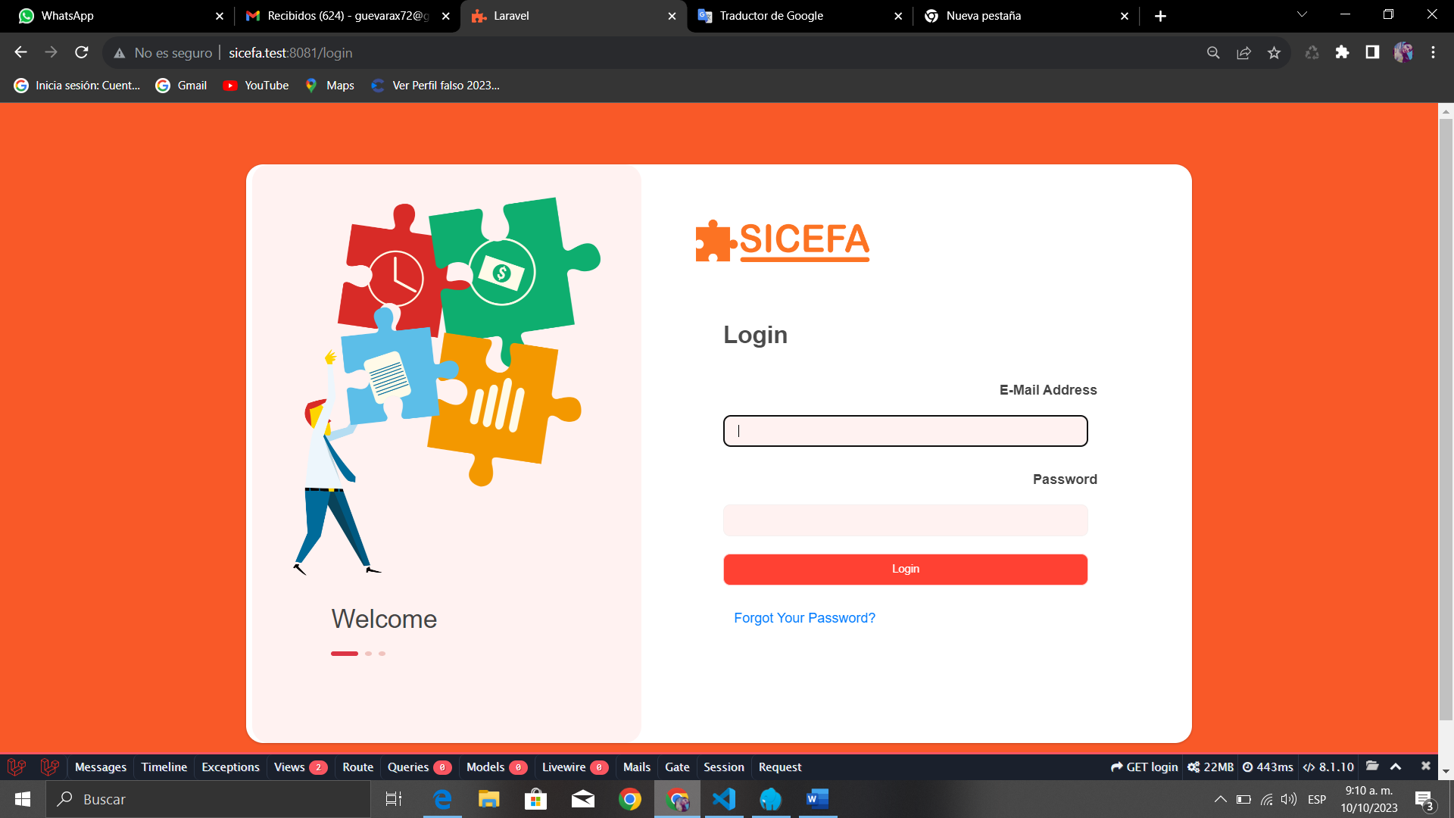

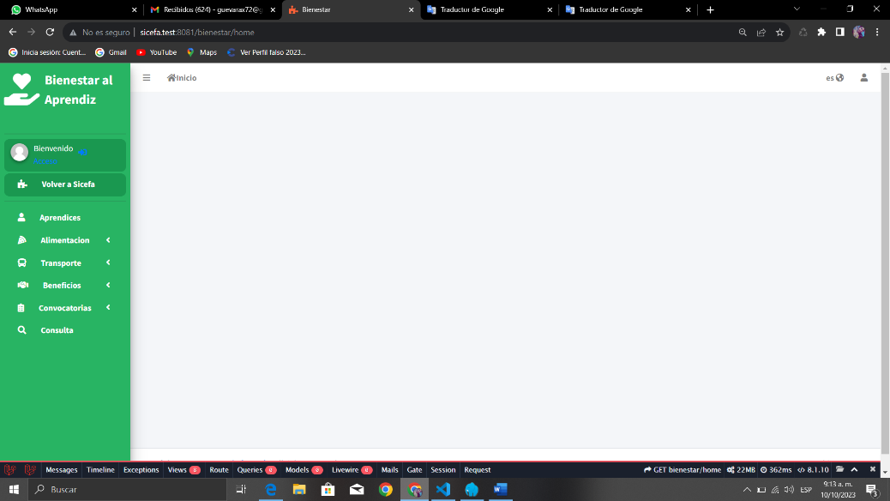

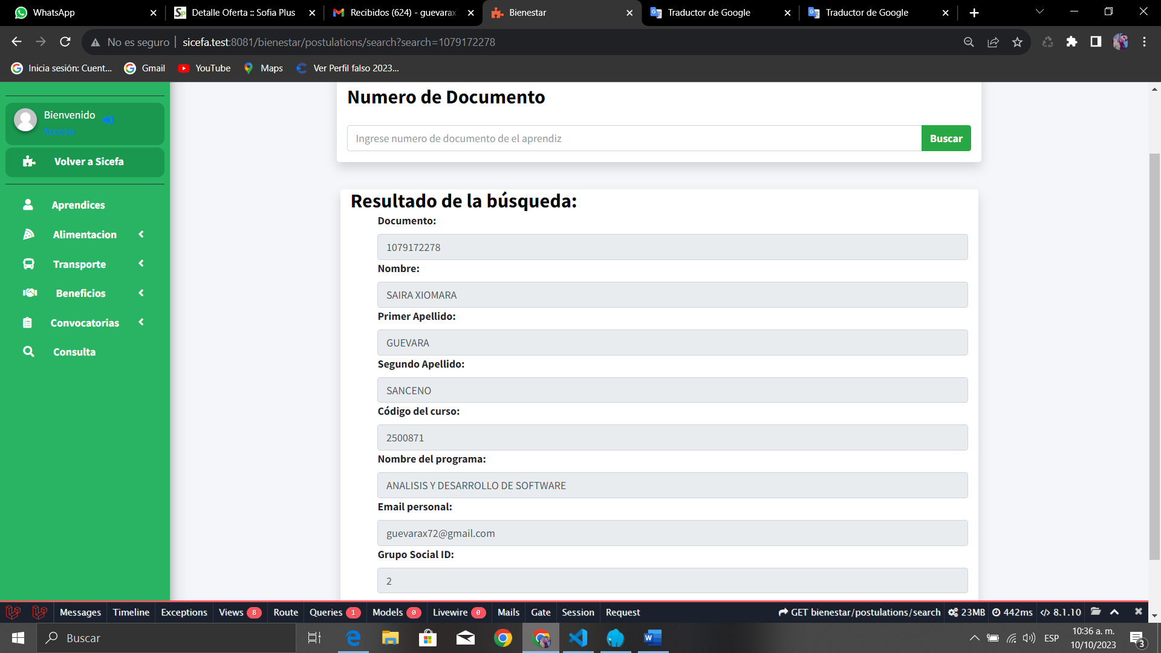

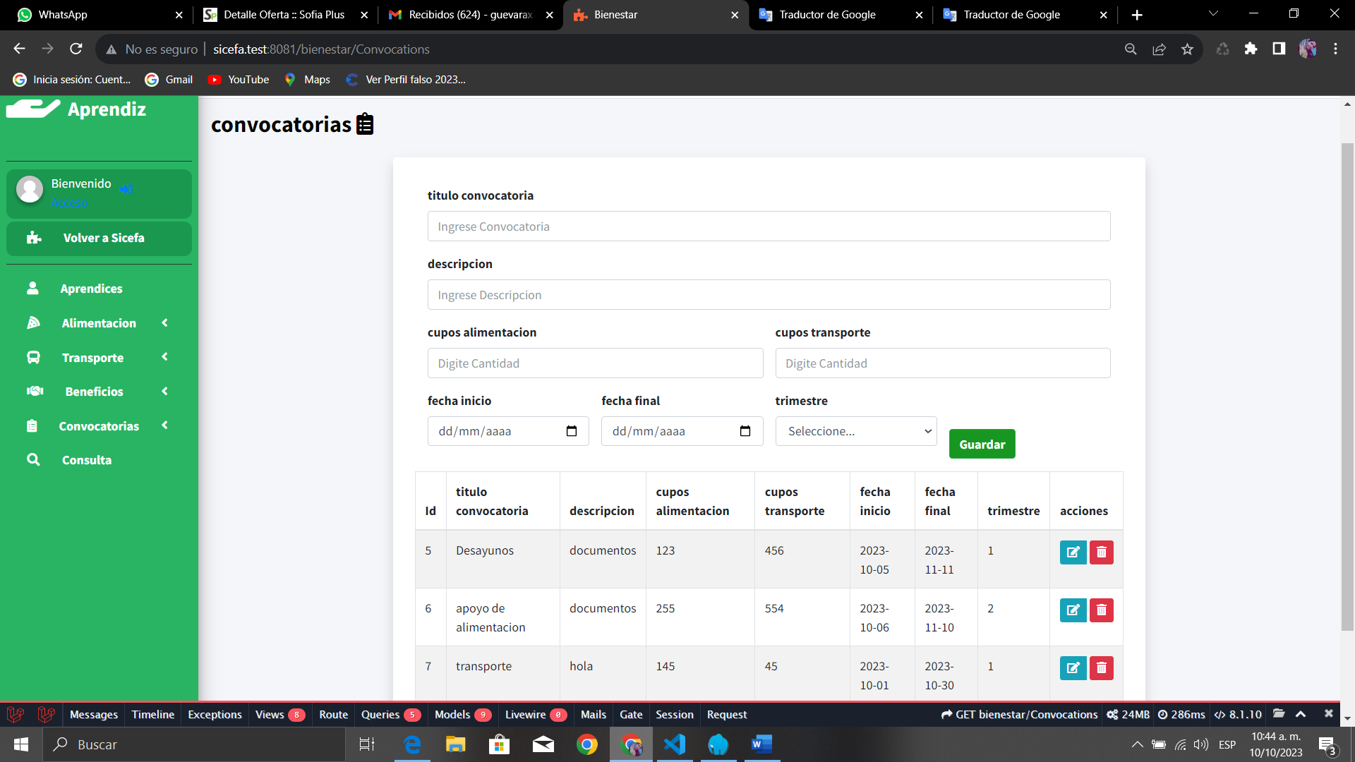

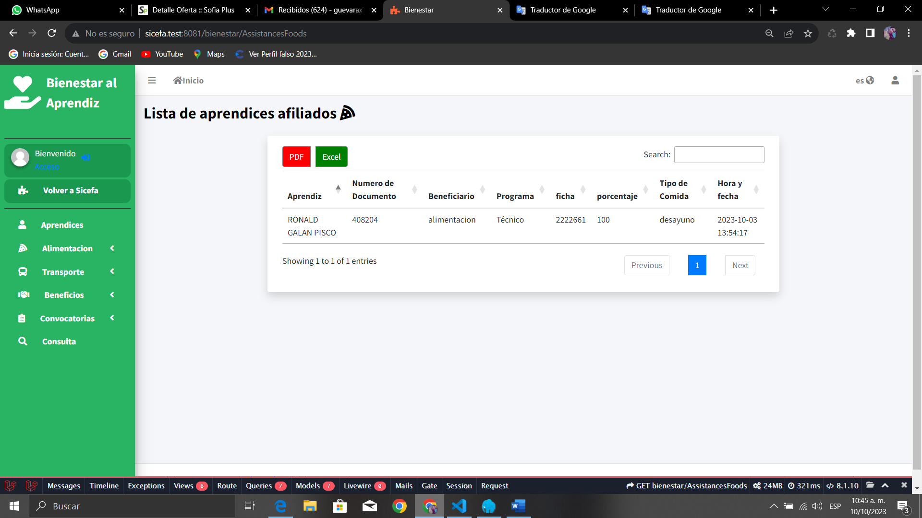

* First, enter the official SICEFA page,
* Then, click on log in
* and finally, type your mail and password.

After logging in the well-being software, the instructors in charge of the food and transportation announcements will send a link where apprentices can send the documents required. After announcements end, apprentices access the software and with their document number verify the benefits they got.

In addition, our software provides the following tasks:

* Identification of each apprentice at the training center which includes program code and the benefit they already have.
* Database that stores attendance information, and the record of linked apprentices.
* characterization of information about each apprentice to generate a quarterly report.
* And consultation field for each apprentice, so that instructors will have access to each apprentice information.

1. The tools we used to develop our project were:

* the Laravel framework,
* a database called Laragon,
* and a visual studio code to design the software.

4. Our innovation idea consist on creating a software that hold digital information about the benefits the well-being area offer to apprentices, so they no longer will use manual registration.